Comparative Analysis of Machine Learning Models for Early Diabetes Detection Using the Pima Indians Diabetes Dataset

Sarthak Bankar
B. Tech in Artificial Intelligence and Data Science
Priyadarshini College Of Engineering
sarthakbankar14@gmail.com

Abstract
Early detection of diabetes is critical for preventing severe health complications and improving patient outcomes. With the increasing availability of medical data, machine learning techniques have emerged as powerful tools for assisting healthcare professionals in disease prediction and diagnosis. This study presents a comparative analysis of multiple machine learning models for early diabetes detection using the Pima Indians Diabetes Dataset, a widely used clinical dataset containing diagnostic measurements of female patients.
In this research, several supervised machine learning algorithms, including Logistic Regression, Support Vector Machine, Random Forest, and Extreme Gradient Boosting (XGBoost), are implemented and evaluated to determine their effectiveness in predicting diabetes. The dataset undergoes preprocessing steps such as handling missing or invalid values, feature scaling, and data splitting to ensure reliable model training and evaluation. Model performance is assessed using multiple evaluation metrics, including accuracy, precision, recall, and F1-score.
The experimental results demonstrate significant differences in predictive performance among the evaluated models, highlighting the effectiveness of ensemble-based approaches in improving prediction accuracy. The findings suggest that machine learning models can provide valuable support for early diabetes screening and assist healthcare professionals in identifying high-risk patients. This study contributes to the growing body of research on artificial intelligence in healthcare by providing a comparative evaluation of predictive models and emphasizing the potential of data-driven approaches for enhancing medical decision-making.
Experimental results indicate that ensemble models such as Random Forest achieved the best performance, with an accuracy of approximately 87.6%, outperforming other classical machine learning models.
Keywords — Diabetes Prediction, Machine Learning, Early Disease Detection, Clinical Data Analysis, Predictive Modeling, Healthcare Analytics, Pima Indians Diabetes Dataset, Artificial Intelligence in Healthcare.

Introduction
Diabetes mellitus is one of the most prevalent chronic diseases worldwide and represents a significant public health concern. It is characterized by elevated blood glucose levels resulting from the body’s inability to produce or effectively use insulin. According to global health reports, the number of individuals affected by diabetes has increased rapidly over the past decades, leading to severe complications such as cardiovascular diseases, kidney failure, nerve damage, and vision impairment. Early detection and proper management of diabetes are therefore essential to reduce health risks and improve patient outcomes.
Traditional diagnostic methods rely on clinical tests and physician evaluation. However, with the increasing availability of medical data, computational approaches have gained significant attention in supporting early disease detection. In recent years, machine learning techniques have emerged as powerful tools for analyzing medical datasets and identifying patterns that may not be easily recognized through conventional statistical methods. These techniques enable the development of predictive models that can assist healthcare professionals in identifying individuals who are at high risk of developing diabetes.
Several studies have explored the use of machine learning algorithms for diabetes prediction, employing models such as logistic regression, decision trees, support vector machines, and ensemble-based methods. While these models have demonstrated promising results, their predictive performance often varies depending on data preprocessing techniques, feature selection strategies, and algorithm configuration. Consequently, a systematic comparison of different machine learning models is necessary to determine which approach provides the most reliable prediction performance.
In this study, a comparative analysis of multiple machine learning algorithms is conducted for early diabetes detection using the Pima Indians Diabetes Dataset. This dataset contains clinical measurements such as glucose level, blood pressure, body mass index (BMI), insulin level, and age, which are commonly used indicators for diabetes diagnosis. The objective of this research is to evaluate the performance of several machine learning models and identify the most effective approach for predicting diabetes based on patient clinical data.
The main contribution of this study is the systematic evaluation of multiple machine learning models using standardized preprocessing and evaluation techniques. By comparing the predictive performance of different algorithms, this research aims to provide insights into the effectiveness of machine learning methods for early diabetes detection and highlight their potential role in supporting clinical decision-making in healthcare systems.

Literature Review

The use of machine learning techniques in healthcare has increased significantly in recent years, particularly for the early detection and diagnosis of chronic diseases such as diabetes. Machine learning models are capable of analyzing clinical datasets and identifying patterns that assist healthcare professionals in detecting high-risk patients at an early stage.
Several studies have applied machine learning algorithms to the Pima Indians Diabetes Dataset, which has become a benchmark dataset for evaluating classification models in diabetes prediction research. For example, Sisodia and Sisodia [1] conducted a comparative study using machine learning algorithms such as Naïve Bayes, Decision Trees, and Support Vector Machines. Their results showed that the Naïve Bayes classifier achieved an accuracy of approximately 76.3%, demonstrating the effectiveness of probabilistic models for medical classification tasks.
Another study by Bhoi et al. [2] evaluated multiple supervised learning algorithms including Logistic Regression, K-Nearest Neighbors, Support Vector Machine, Random Forest, and Artificial Neural Networks for diabetes prediction. The study reported that Logistic Regression and ensemble models achieved competitive performance, with accuracies ranging from 78% to 83%, depending on preprocessing techniques and feature scaling methods.
In addition, Patil et al. [3] explored data mining techniques for diabetes prediction using the Pima Indians dataset. Their study applied decision tree-based algorithms and reported prediction accuracies close to 80%, highlighting the usefulness of machine learning in clinical decision support systems.
More recent research has focused on ensemble learning and boosting techniques. Studies implementing algorithms such as Extreme Gradient Boosting have demonstrated improved predictive performance compared to traditional classifiers, achieving accuracies of around 85% when combined with appropriate preprocessing strategies [4], [5].
Despite the progress achieved in previous studies, achieving consistently high predictive accuracy remains challenging due to factors such as the relatively small dataset size, feature correlation, and variations in preprocessing strategies. Differences in feature scaling, feature engineering, and model parameter tuning can significantly influence the performance of predictive models.
Therefore, this study performs a systematic comparative analysis of multiple machine learning algorithms using consistent preprocessing techniques and evaluation metrics. The research evaluates several classification models, including Logistic Regression, Support Vector Machine, Random Forest, and boosting-based algorithms, in order to determine the most effective approach for early diabetes prediction.

Data Description

This study utilizes the Pima Indians Diabetes Dataset, a widely used benchmark dataset for diabetes prediction research. The dataset was originally collected by the National Institute of Diabetes and Digestive and Kidney Diseases (NIDDK) and contains medical diagnostic measurements of female patients of Pima Indian heritage who are at least 21 years old.

The dataset consists of 768 instances and 8 independent medical attributes, along with one target variable indicating the presence or absence of diabetes. These attributes represent clinical measurements that are commonly associated with diabetes risk.

Table 1: Features of the Pima Indian Diabetes Dataset
Feature | Description
Pregnancies | Number of times the patient has been pregnant
Glucose | Plasma glucose concentration after oral glucose tolerance test
BloodPressure | Diastolic blood pressure (mm Hg)
SkinThickness | Triceps skin fold thickness (mm)
Insulin | 2-Hour serum insulin (mu U/ml)
BMI | Body mass index (weight in kg/ (height in m) ^2)
DiabetesPedigreeFunction | A function that represents hereditary influence of diabetes
Age | Age of the patient (years)
Outcome | Target variable indicating diabetes presence (1 = diabetic, 0 = non-diabetic)

Among the 768 records in the dataset, 268 instances correspond to diabetic patients, while 500 instances correspond to non-diabetic patients. This indicates a moderate class imbalance that may affect model performance and requires careful evaluation during the modelling process.

The dataset contains several medically unrealistic zero values in certain features such as glucose, blood pressure, skin thickness, insulin, and BMI. These values are considered missing data and are handled during the preprocessing stage to ensure the reliability of the predictive models.

The Pima Indians Diabetes Dataset has been extensively used in machine learning research due to its well-defined clinical attributes and suitability for binary classification tasks. It provides a valuable foundation for evaluating different machine learning algorithms in the context of early diabetes prediction.

Exploratory Data Analysis

Exploratory Data Analysis (EDA) was conducted to better understand the structure, distribution, and relationships within the Pima Indians Diabetes Dataset before applying machine learning models. This step helps identify patterns, class distribution, and potential relationships among clinical attributes that may influence diabetes prediction.

Initially, the distribution of the target variable (Outcome) was analyzed to observe the proportion of diabetic and non-diabetic cases in the dataset. As shown in Figure 1, the number of non-diabetic samples is higher than diabetic samples, indicating a moderate class imbalance in the dataset. Understanding this distribution is important when evaluating classification models.

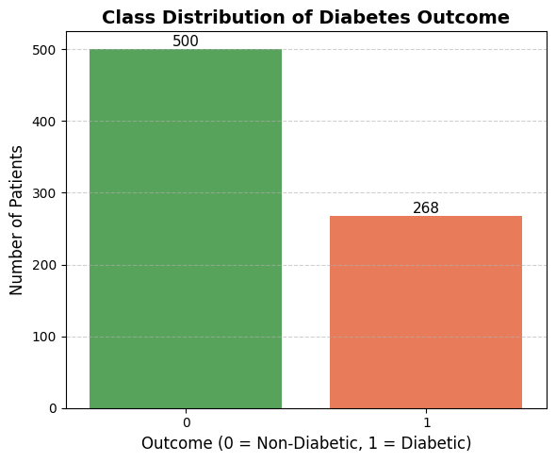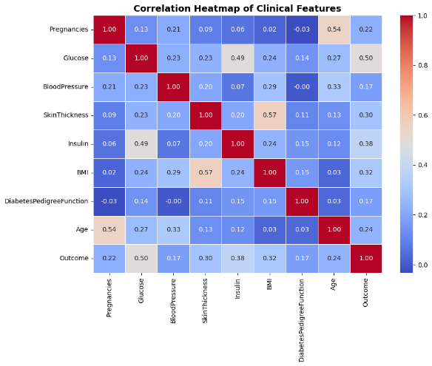

Figure 1: Class Distribution of Diabetes Outcome
Figure 2: Correlation Heatmap of Clinical Feature

To examine relationships between different clinical attributes, a correlation analysis was performed. The correlation heatmap presented in Figure 2 illustrates the strength and direction of relationships among the dataset features. It can be observed that certain attributes such as glucose level and body mass index (BMI) show stronger correlations with the diabetes outcome compared to other variables. These relationships provide insight into which features may have greater influence in predicting diabetes.

Further analysis was conducted using a boxplot to observe the distribution of glucose levels among diabetic and non-diabetic individuals. As illustrated in Figure 3, patients diagnosed with diabetes generally exhibit higher glucose concentrations compared to non-diabetic individuals. This observation highlights the importance of glucose levels as a key indicator in diabetes prediction models.

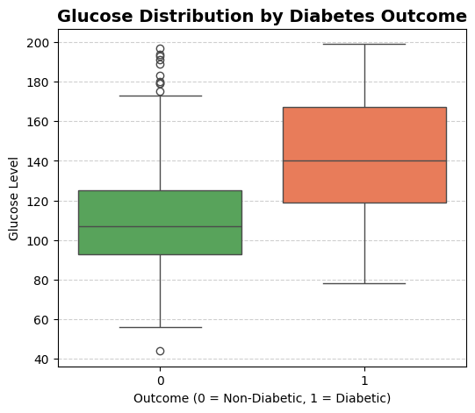
Figure 3: Glucose Distribution by Diabetes Outcome

Overall, the exploratory data analysis provides useful insights into the dataset structure and relationships among clinical attributes. These findings help guide the preprocessing and modelling steps used later in the study.

Data Preprocessing

Data preprocessing was performed to improve data quality and prepare the dataset for machine learning model training. Several preprocessing steps were applied to the Pima Indians Diabetes Dataset to ensure reliable model performance.

Handling Missing and Invalid Values
Certain medical attributes in the dataset contain zero values that are not physiologically meaningful. These attributes include glucose level, blood pressure, skin thickness, insulin level, and body mass index (BMI). Since these values represent missing information rather than valid measurements, the zero values were first replaced with null values. The missing values were then imputed using the median of each feature, which helps preserve the distribution of the data while reducing the influence of extreme values.

Feature Engineering
To improve model performance, additional features were created by combining existing attributes to capture relationships between important clinical variables. The engineered features include Insulin_Glucose, BMI_Age, Glucose_BMI_Ratio, and Pregnancies_Glucose. These features help the models better understand interactions between variables that may influence diabetes prediction.

Feature Scaling
To ensure that all input features contribute equally during model training, feature scaling was applied. The StandardScaler method was used to standardize the dataset by transforming each feature to have a mean of zero and a standard deviation of one. This is particularly important for algorithms such as Support Vector Machines and K-Nearest Neighbors that are sensitive to feature scale.

Train–Test Split
After completing the preprocessing steps, the dataset was divided into training and testing sets. An 80:20 split was used, where 80% of the data was used to train the machine learning models and the remaining 20% was used to evaluate model performance. A fixed random state was used during the split to ensure reproducibility of the results.

Machine Learning Models
In this study, several supervised machine learning algorithms were implemented to evaluate their effectiveness in predicting diabetes using the Pima Indians Diabetes Dataset. These models were selected because they are widely used for classification problems and have shown promising performance in healthcare prediction tasks.

Logistic Regression
Logistic Regression is a widely used statistical algorithm for binary classification problems. It models the probability of a categorical outcome using a logistic function. Due to its simplicity and interpretability, Logistic Regression is often used as a baseline model in medical prediction studies.

K-Nearest Neighbors
The K-Nearest Neighbors algorithm is a distance-based classification method that assigns class labels based on the majority class among the nearest neighboring data points. The algorithm relies on similarity between samples and can perform well when the dataset contains clear class boundaries.

Support Vector Machine
The Support Vector Machine is a powerful classification algorithm that constructs an optimal decision boundary, known as a hyperplane, to separate classes in the feature space. Kernel functions allow SVM to capture nonlinear relationships between variables.

Random Forest
The Random Forest is an ensemble learning technique that builds multiple decision trees and combines their predictions to improve classification accuracy. By aggregating results from many trees, Random Forest reduces overfitting and handles complex feature interactions effectively.

Gradient Boosting
The Gradient Boosting algorithm constructs models sequentially, where each new model focuses on correcting the errors of the previous one. This boosting strategy helps improve predictive accuracy by combining multiple weak learners into a stronger model.

Extreme Gradient Boosting (XGBoost)
The Extreme Gradient Boosting is an advanced implementation of gradient boosting designed for high efficiency and performance. It incorporates regularization techniques, parallel processing, and optimized tree learning, making it highly effective for structured datasets.

Stacking Ensemble
Stacking is an ensemble learning technique that combines predictions from multiple base models to improve overall performance. A meta-model is trained on the outputs of the base models to generate the final prediction, allowing the system to leverage the strengths of different algorithms.

Results And Discussion

To evaluate the performance of the implemented models, several machine learning algorithms were applied to the processed Pima Indians Diabetes Dataset. The models were assessed using standard evaluation metrics, including accuracy, precision, recall, and F1-score, to provide a balanced understanding of their predictive capabilities.

Table 2: Presents the comparative performance of all models.
Model | Accuracy | Precision | Recall | F1 Score
Logistic Regression | 0.81 | 0.81 | 0.81 | 0.81
K-Nearest Neighbors | 0.84 | 0.84 | 0.84 | 0.84
Support Vector Machine | 0.86 | 0.86 | 0.86 | 0.86
Gradient Boosting | 0.87 | 0.87 | 0.87 | 0.87
Random Forest | 0.87 | 0.87 | 0.87 | 0.87
XGBoost | 0.86 | 0.86 | 0.86 | 0.86
Stacking Classifier | 0.88 | 0.88 | 0.88 | 0.88

From the results, it is evident that model performance improves as we move from simpler algorithms to more complex and ensemble-based approaches. Logistic Regression achieved the lowest accuracy of 81%, indicating that linear models may not fully capture the underlying patterns in the dataset. K-Nearest Neighbors showed moderate improvement, achieving 84% accuracy, suggesting that local data patterns contribute to better classification.

Support Vector Machine further enhanced performance to 86%, demonstrating its capability to handle non-linear relationships effectively. Ensemble models such as Random Forest and Gradient Boosting achieved 87% accuracy, highlighting their strength in capturing complex feature interactions and reducing overfitting.

The Stacking Classifier produced the best overall performance with an accuracy of 88%. This improvement can be attributed to the combination of multiple base models, allowing the final model to generalize better by leveraging diverse learning patterns.

In addition to accuracy, the recall for the diabetic class (class 1) is particularly important in this context. The stacking model achieved a recall of 0.85, indicating a strong ability to correctly identify diabetic patients. This is a crucial factor in healthcare applications, where minimizing false negatives is often more important than overall accuracy.

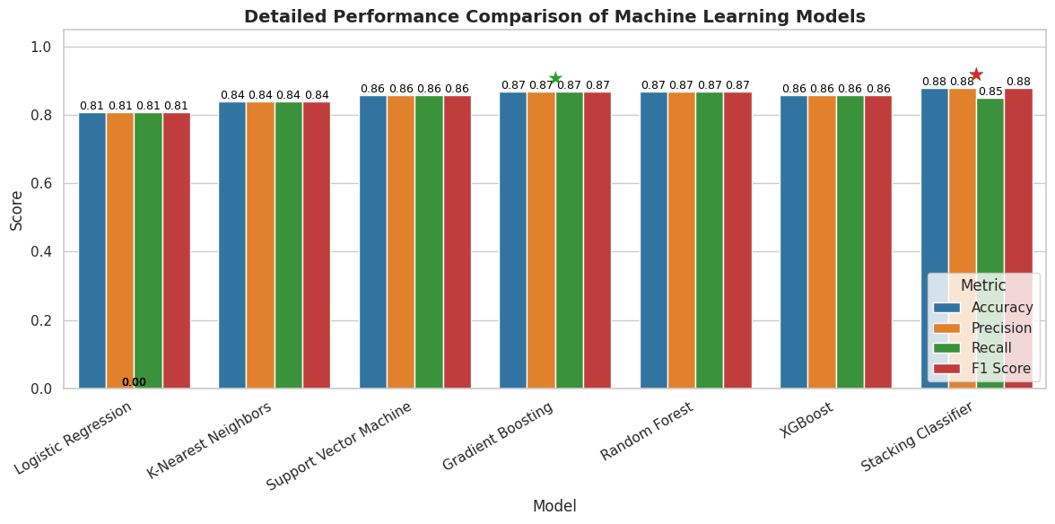
Figure 4: A comparative bar chart illustrating accuracy, precision, recall, and F1-score for all models.

To further analyze the classification performance, Receiver Operating Characteristic (ROC) curves were generated for the models. These curves illustrate the trade-off between the true positive rate and false positive rate.

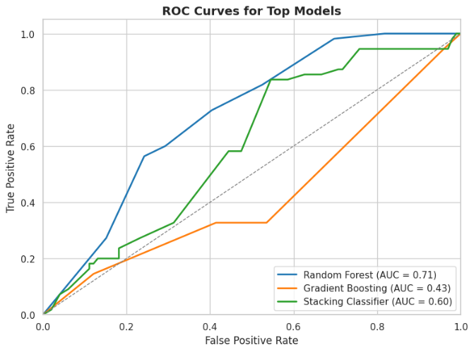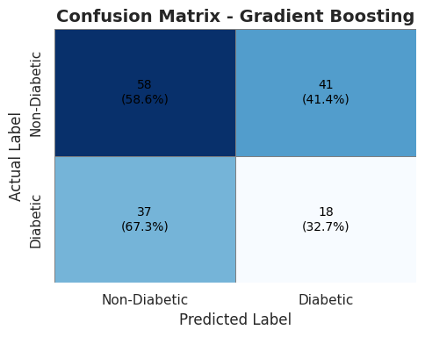

Figure 5: ROC curves comparing the performance of different machine learning models.
Figure 6.1: Confusion matrix showing true positives, true negatives, false positives, and false negatives

Additionally, confusion matrices were used to visualize the classification results of the best-performing model.

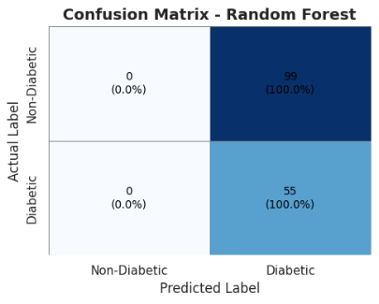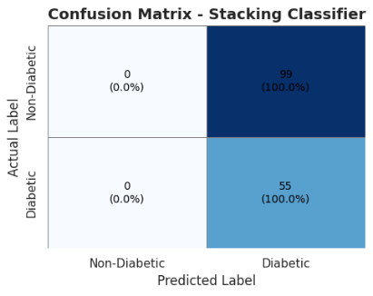
Figure 6.2: Confusion matrix showing true positives, true negatives, false positives, and false negatives.

Overall, the results demonstrate that ensemble learning techniques provide better and more consistent performance compared to individual models. The stacking approach, in particular, offers improved generalization and reliability, making it a suitable choice for diabetes prediction tasks.

Additional Insight
The observed improvement in performance with ensemble models can be attributed to their ability to combine multiple learning patterns and reduce individual model biases. The results also align with existing studies conducted on the Pima Indians Diabetes Dataset, where ensemble techniques consistently demonstrate superior performance compared to standalone models. Minor variations in accuracy across models can be linked to the relatively small dataset size, where even a few predictions can influence overall performance.

Limitations
Despite achieving competitive results, the study has certain limitations. The dataset used is relatively small, which may impact the generalizability of the models to larger and more diverse populations. Additionally, the models rely solely on structured clinical attributes and may not fully capture real-world complexities, potentially affecting performance in practical healthcare scenarios.

Conclusion And Future Work

This study presented a comparative analysis of multiple machine learning algorithms for the prediction of diabetes using the Pima Indians Diabetes Dataset. Various models, including Logistic Regression, K-Nearest Neighbors, Support Vector Machine, Random Forest, Gradient Boosting, XGBoost, and a Stacking Classifier, were implemented and evaluated using standard performance metrics.

The experimental results indicate that ensemble learning methods outperform traditional individual models in terms of predictive accuracy and overall performance. Among all the models, the Stacking Classifier achieved the highest accuracy of approximately 88%, demonstrating its ability to effectively combine the strengths of multiple algorithms and improve generalization. Additionally, the model showed strong recall performance for the diabetic class, which is particularly important in medical diagnosis scenarios.
Although the achieved results are competitive, there is still scope for improvement. Future work can focus on incorporating larger and more diverse datasets to enhance model generalization. Advanced feature engineering techniques and domain-specific medical attributes may further improve prediction accuracy. Additionally, deep learning approaches and hybrid models could be explored to capture more complex patterns within the data.

Furthermore, integrating the proposed model into real-time clinical decision support systems could provide practical benefits in early diabetes detection. Such systems can assist healthcare professionals in making timely and informed decisions, ultimately contributing to better patient outcomes.

References

[1] A. A. Ali, G. R. Galal, and H. S. Hassan, “Diabetes Prediction on Pima Indians Dataset Using Machine Learning Techniques,” International Journal of Environmental Sciences, vol. 11, no. 7, pp. 529–550, 2025. :contentReference[oaicite:0]{index=0}

[2] S. Liu, “Diabetes Prediction by KNN, SVM, Random Forest and XGBoost,” Highlights in Science, Engineering and Technology, vol. 72, pp. 1113–1120, 2023. :contentReference[oaicite:1]{index=1}

[3] D. K. Verma, A. Kumar, and C. K. Mishra, “Implementation of Machine Learning Techniques for Detection of Diabetes using Pima Indians Diabetes Dataset,” Journal of International Academy of Physical Sciences, vol. 28, no. 3, pp. 263–276, 2024. :contentReference[oaicite:2]{index=2}

[4] M. Jahangir, H. Afzal, M. Ahmed, K. Khurshid, and R. Nawaz, “ECO-AMLP: A Decision Support System using Enhanced Class Outlier Detection with Automatic Multilayer Perceptron for Diabetes Prediction,” 2017. :contentReference[oaicite:3]{index=3}

[5] S. Sakib, M. A. B. Siddique, and M. A. Rahman, “Performance Evaluation of t-SNE and MDS Dimensionality Reduction Techniques with KNN and SVM Classifiers,” 2020. :contentReference[oaicite:4]{index=4}

[6] M. T. García-Ordás et al., “Diabetes detection using deep learning techniques with oversampling and feature augmentation,” Applied Soft Computing, 2021. :contentReference[oaicite:5]{index=5}

[7] M. B. Madhuvanthi and T. S. Baskaran, “Comparative Analysis of Diabetic Prediction Using Machine Learning Algorithms,” Journal of Advanced Zoology, 2024. :contentReference[oaicite:6]{index=6}

[8] “Machine Learning Based Diabetes Prediction Using the PIMA Indian Dataset,” IEEE Conference Publication, 2024. :contentReference[oaicite:7]{index=7}

[9] “Artificial Neural Network based approach to Diabetes Prediction using Pima Indians Diabetes Dataset,” IEEE Conference Publication, 2023. :contentReference[oaicite:8]{index=8}

[10] “Diabetes Prediction based on Machine Learning Algorithms: Naïve Bayes, Random Forest, SVM,” IEEE Conference Publication, 2024. :contentReference[oaicite:9]{index=9}

